Streaming Revenue Driver Model Final Report v3
Standalone final documentation for the streaming revenue model
Prepared: April 1, 2026
Confidence score: 64/100

Table of Contents
Right-click and update field to generate the table of contents.

Executive Summary
This v3 streaming report corrects the second deep-audit findings by fixing subscriber accounting, widening scenario ranges, documenting curve provenance, adding cohort aging logic, and distinguishing sourced, derived, and assumed components. Subscriber accounting now satisfies the explicit bridge identity every month: Ending Subscribers = Beginning Subscribers - Gross Churn + New Adds + Total Reactivations.
The base-case streaming model reaches Month 24 ARR of 160,952.24. The recession scenario falls to 89,665.43, the competition scenario to 78,962.40, and the saturation scenario to 94,798.57. This wider range addresses the prior critique that sensitivity was implausibly tight.
The confidence score is 64/100. This lower score is deliberate and honest. The model is now structurally better, but still benchmark-calibrated and partially assumption-driven, especially in involuntary recovery timing.

How This Model Supports the LinkedIn Article
The LinkedIn article claims that forecasting is strongest when the business system underneath revenue is visible. The streaming v3 model shows that clearly. Subscriber acquisition, churn, reactivation, pricing, leakage, expansion, and contraction all interact before they become ARR. This makes the model explainable and falsifiable in a way a top-line extrapolation is not.

Data Sources and Provenance
Element | Status | Methodology | URL
Streaming voluntary reactivation curve | Sourced + interpolated | Antenna cumulative voluntary resubscription points: 10% by month 1, 23% by month 3, 37% by month 9, 41% by month 12. Monthly rates are linearly interpolated between observed cumulative points. | https://www.antenna.live/insights/resubscription-is-on-the-rise
Streaming involuntary recovery curve | Derived from sourced aggregate | Recurly reports average decline-management efficiency of 69.4%. Monthly curve is derived to sum to 69.4% over 6 months: [35.0%, 15.0%, 9.0%, 5.0%, 3.0%, 2.4%]. | https://recurly.com/research/subscriber-retention-benchmarks/
Repeat reactivation handling | Structural, not multiplier-based | No arbitrary repeat multipliers are used in v3. Any churn event re-enters the appropriate future reactivation pool under the same sourced/derived curve rules. | Model design choice

Operator Benchmark Inputs
Platform | Subscribers_Millions | ARPU | Metric | URL
Netflix | 301.63 | 11.70 | 2024 global ARM / Q4 2024 subscribers | https://ir.netflix.net/financials/annual-reports-and-proxies/default.aspx
Disney+ | 158.60 | 7.20 | Q4 2024 subscribers / ARPU | https://www.sec.gov/Archives/edgar/data/1744489/000174448924000275/fy2024_q4xprxex991.htm
WBD DTC | 116.90 | 7.44 | Q4 2024 DTC subscribers / ARPU | https://www.wbd.com/news/warner-bros-discovery-reports-fourth-quarter-and-full-year-2024-results

What Changed in v3
- Fixed subscriber bridge accounting and added a monthly bridge check.
- Replaced narrow scenario ranges with bull, recession, competition, and saturation cases.
- Added tenure-bucket cohort aging to churn behavior.
- Removed arbitrary repeat-reactivation multipliers.
- Clarified voluntary reactivation as sourced + interpolated and involuntary recovery as derived from a sourced aggregate.
- Removed calendar-based promotional timing and replaced it with scenario-driven pricing pressure.

Model Structure
The streaming model begins with rate-card MRR and derives beginning subscribers using subscriber-weighted ARPU. Subscribers are held in cohort objects with age and type. Age determines tenure bucket. Type distinguishes organic and reactivated cohorts. Churn is then cohort-specific and responsive to pricing pressure, competition pressure, macro shock, and seasonality. Churned subscribers enter voluntary or involuntary pools and can later return through sourced or transparently derived recovery curves.
Revenue is then built from ending subscribers multiplied by ARPU to produce rate-card MRR. Effective MRR applies billing leakage. Net expansion MRR is added after that to capture installed-base monetization not already embedded in ARPU. This prevents the v2 monetization confusion.

Key v3 Results
Metric | Value
Base Month24 ARR | 160,952.24
Bull Month24 ARR | 240,567.57
Recession Month24 ARR | 89,665.43
Competition Month24 ARR | 78,962.40
Saturation Month24 ARR | 94,798.57
Average base net churn rate | 0.0235
Average base dampening | 0.3267
Weighted ARPU | 9.60
Simple ARPU average | 8.78

Scenario Analysis
Scenario analysis now fully re-runs the model under materially different assumptions. The recession case lowers acquisition, increases churn pressure, and reduces monetization power. The competition case raises churn and acquisition drag. The saturation case reduces addressable acquisition headroom. The bull case improves demand and pricing.
Scenario | Month24 Total MRR | Month24 ARR | Average Net Churn Rate | Average Reactivation Dampening % | Minimum ARR Run Rate
bull | 20,047.30 | 240,567.57 | 0.0234 | 0.3221 | 142,962.94
base | 13,412.69 | 160,952.24 | 0.0235 | 0.3267 | 137,808.14
recession | 7,472.12 | 89,665.43 | 0.0265 | 0.3375 | 89,665.43
competition | 6,580.20 | 78,962.40 | 0.0262 | 0.3374 | 78,962.40
saturation | 7,899.88 | 94,798.57 | 0.0240 | 0.3413 | 94,798.57

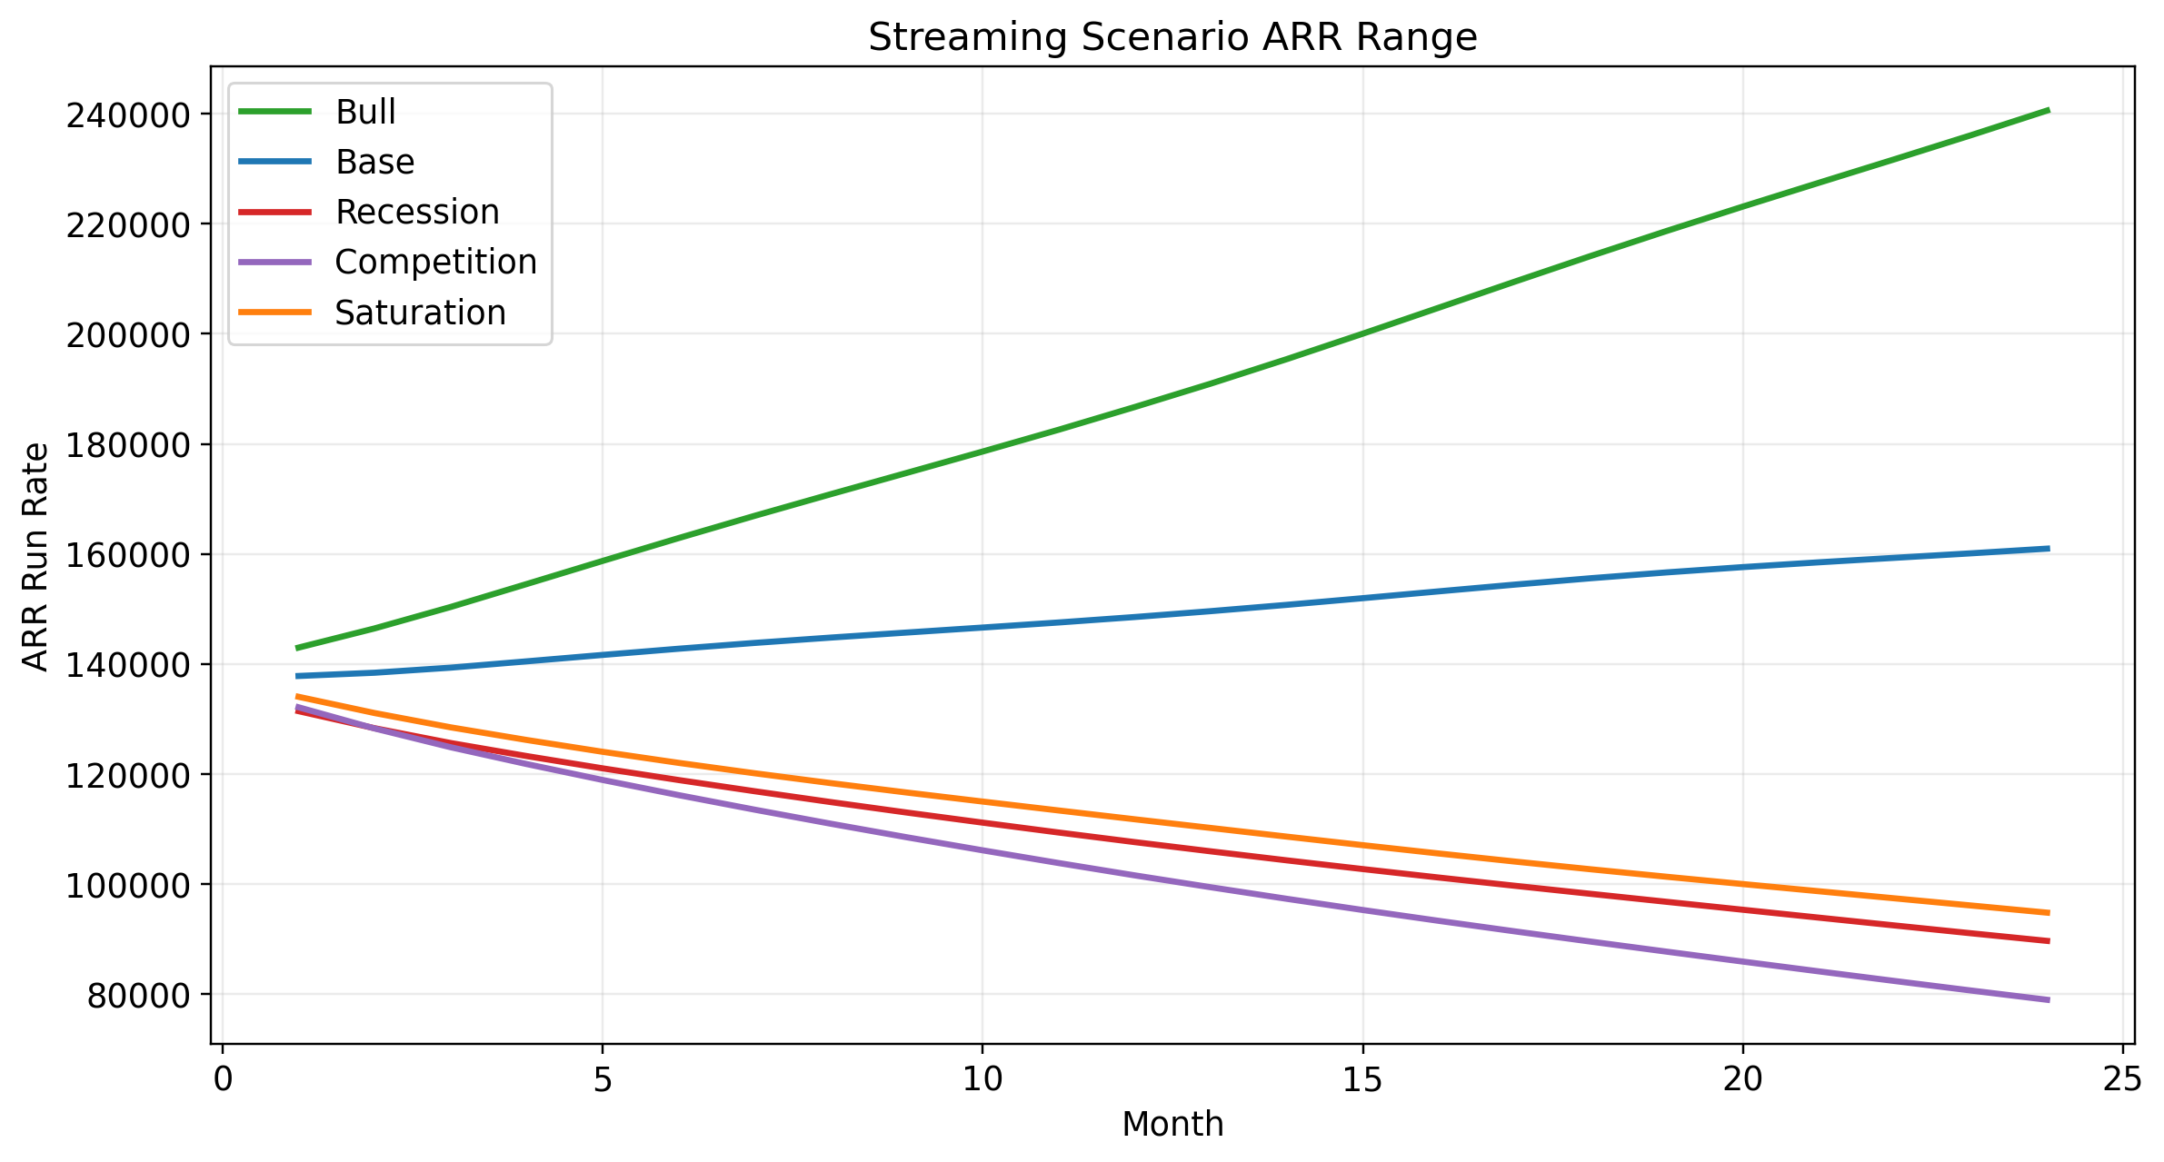
Figure 1. Streaming ARR path across full rerun scenarios.

Churn, Reactivation, and Bridge Integrity
The base-case streaming bridge now balances exactly every month. Reactivation dampening is reported directly, and month 1 net churn correctly reflects no reactivation offset. Voluntary and involuntary churn are tracked separately, and involuntary recovery extends through month 6 rather than ending abruptly at month 4.
Month | Beginning Subscribers | New Adds | Gross Churn | Total Reactivations | Ending Subscribers | Bridge Check | Net Churn Rate | Reactivation Dampening %
1 | 1,252.65 | 33.40 | 39.85 | 0 | 1,246.20 | 0 | 0.0318 | 0
2 | 1,246.20 | 35.45 | 41.16 | 5.98 | 1,246.47 | -0 | 0.0282 | 0.1452
3 | 1,246.47 | 36.92 | 42.53 | 8.82 | 1,249.68 | 0 | 0.0270 | 0.2073
4 | 1,249.68 | 37.43 | 43.50 | 11.25 | 1,254.86 | -0 | 0.0258 | 0.2586
5 | 1,254.86 | 36.86 | 43.92 | 12.34 | 1,260.14 | 0 | 0.0252 | 0.2810
6 | 1,260.14 | 35.35 | 43.73 | 13.25 | 1,265.01 | -0 | 0.0242 | 0.3031
7 | 1,265.01 | 33.32 | 43.14 | 14 | 1,269.19 | 0 | 0.0230 | 0.3246
8 | 1,269.19 | 31.29 | 42.46 | 14.53 | 1,272.56 | 0 | 0.0220 | 0.3423
9 | 1,272.56 | 29.80 | 41.91 | 14.98 | 1,275.43 | 0 | 0.0212 | 0.3573
10 | 1,275.43 | 29.25 | 41.91 | 15.39 | 1,278.16 | -0 | 0.0208 | 0.3673
11 | 1,278.16 | 29.76 | 42.59 | 15.65 | 1,280.99 | 0 | 0.0211 | 0.3676
12 | 1,280.99 | 31.20 | 43.88 | 16.03 | 1,284.34 | 0 | 0.0217 | 0.3653
13 | 1,284.34 | 33.17 | 45.73 | 16.55 | 1,288.34 | 0 | 0.0227 | 0.3620
14 | 1,288.34 | 35.12 | 47.48 | 16.95 | 1,292.93 | 0 | 0.0237 | 0.3571
15 | 1,292.93 | 36.53 | 48.83 | 17.41 | 1,298.05 | 0 | 0.0243 | 0.3566
16 | 1,298.05 | 37.01 | 49.56 | 17.85 | 1,303.35 | -0 | 0.0244 | 0.3602
17 | 1,303.35 | 36.43 | 49.54 | 18.20 | 1,308.43 | -0 | 0.0241 | 0.3673
18 | 1,308.43 | 34.93 | 48.85 | 18.39 | 1,312.90 | 0 | 0.0233 | 0.3766
19 | 1,312.90 | 32.91 | 47.72 | 18.43 | 1,316.52 | -0 | 0.0223 | 0.3862
20 | 1,316.52 | 30.90 | 46.53 | 18.32 | 1,319.21 | 0 | 0.0214 | 0.3938
21 | 1,319.21 | 29.43 | 45.65 | 18.13 | 1,321.11 | 0 | 0.0209 | 0.3972
22 | 1,321.11 | 28.88 | 45.39 | 17.94 | 1,322.55 | 0 | 0.0208 | 0.3952
23 | 1,322.55 | 29.40 | 45.87 | 17.82 | 1,323.90 | -0 | 0.0212 | 0.3885
24 | 1,323.90 | 30.83 | 47.01 | 17.84 | 1,325.55 | 0 | 0.0220 | 0.3794

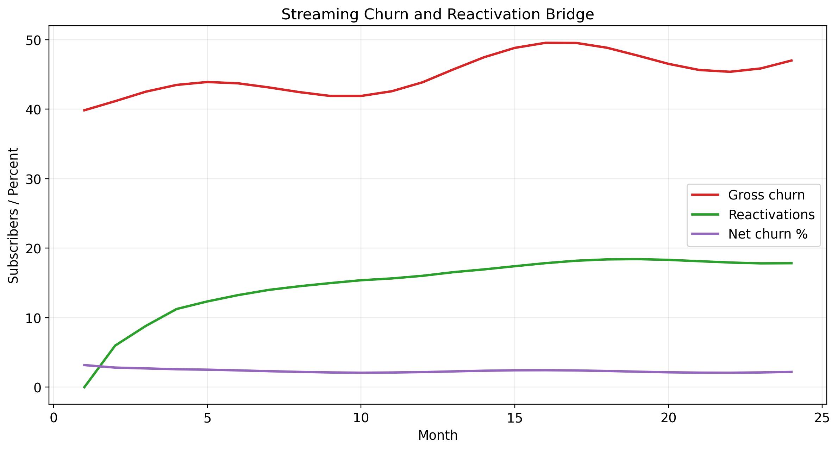
Figure 2. Streaming churn and reactivation bridge in the base case.
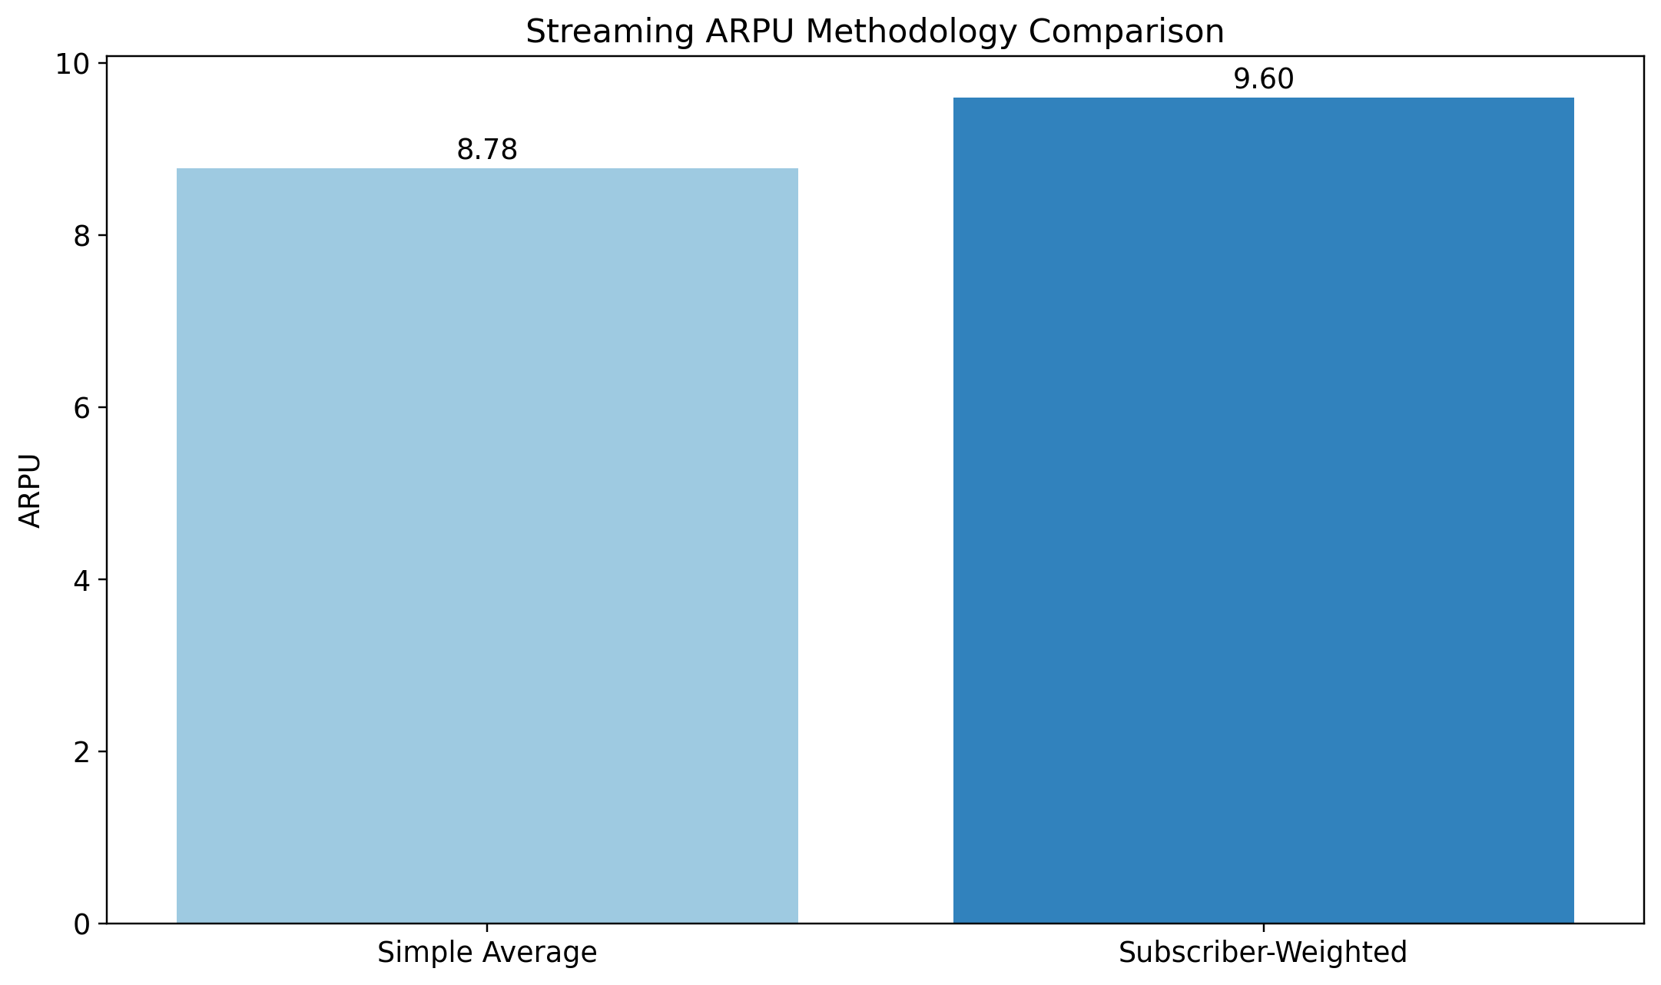
Figure 3. Streaming ARPU methodology comparison.

Transparency, Limitations, and Confidence
- The voluntary reactivation curve is partially interpolated from sourced cumulative points; the involuntary recovery curve is derived from a sourced aggregate recovery figure.
- Streaming CAC remains excluded because confidence is insufficient.
- Churn is now cohort-specific and state-responsive, but still benchmark-calibrated rather than estimated from first-party retention data.
- The 24-month horizon is directionally useful but less reliable beyond month 12.
- Confidence score 64/100 reflects code-level and methodology-level honesty.

